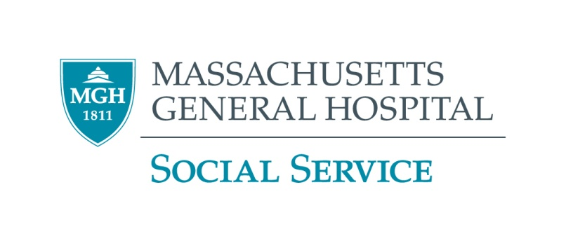

**Emergency Financial Assistance Funds**

**Important Note**

**Do you receive any needs-based benefits** such as SSI, TAFDC, SNAP, housing subsidies, etc.? If so, **before applying for any of these programs** **please get advice from a legal service agency** tolearn how they may affect your benefits.

Find your local legal service agency (free or low-cost if you qualify):

Massachusetts: <http://www.masslegalservices.org/FindLegalAid>

All other states: <http://ptla.org/legal-services-links>

**Massachusetts United Way’s Mass 2-1-1**

Information and referral service- a good place to begin your search. Just dial 211 or see <http://mass211.org/>

**Modest Needs**

**Online only. Financial assistance to low-income working individuals and families in temporary crisis.** <https://www.modestneeds.org>

**Catholic Charities**

Basic Needs Fund provides rent and utility assistance. <https://catholiccharitiesusa.org>

**The Salvation Army**

Provides emergency rent and utilities assistance.

<http://www.salvationarmyusa.org>

**Your City or Town**

Contact your city or town to see if they offer emergency assistance. <http://www.sec.state.ma.us/cis/cistel/telidx.htm>

**Disease or Disability-Specific Funds**

There may be foundations that provide funds for people with your condition. Please consult your social worker for help locating any appropriate resources.

**Additional Agencies**

Also, try calling local religious organizations and local service groups such as the Elks, Jaycees, Kiwanis, Knights of Columbus, Lions and Rotary clubs

**Funds for Greater Boston Residents**

**Jewish Family and Children’s Services**

Provides rent and utilities assistance to **residents of** **greater Boston**, regardless of religion or affiliation. 781-647-JFCS (5327)

**The Lend a Hand Society**

Provides one-time emergency grants for low-income residents of **greater Boston**. **A** **professional must apply on your behalf**: <http://lah.dreamhosters.com/wp-content/uploads/2011/12/Agency-Client-Referral-Form.pdf>. Please mail requests with a cover letter. <http://www.lend-a-hand-society.org>.

**The SWAN Society – for elder single, divorced, or widowed women**

You must be 65 or over and a single, divorced or widowed woman and live within a **25-mile radius of Boston**. **A professional must apply on your behalf.** Call 617-536-7951 or see <http://swansocietyboston.org>. Application: <http://swansocietyboston.org/forms/SWAN-Application.pdf>

**Rogerson Communities Elder Assistance Fund – for Boston elders**

Grants for **very low income Boston residents age 62 or older (or 55 or older and disabled)**. For **one-time** extraordinary expenses. **A professional must write a letter of support.** Call 617-327-1503 and ask for Resident Services Coordinator Giovana Russo.

**Personal Fundraising Websites**

Most charge a fee of about 3-5% of the proceeds. **Please carefully read the fee schedules and other terms of service for these sites.**

Some popular sites:

* [YouCaring.com](http://www.youcaring.com/) – charges lower fees
* [GoFundMe.com](http://www.gofundme.com/) – charges lower fees
* [GoGetFunding.com](http://gogetfunding.com/)
* [Indiegogo.com](http://www.indiegogo.com/)
* [Kickstarter.com](https://www.kickstarter.com/)